MINI PROJECT **(2021-22) “GLA**

**CSED-Website”**

Project Report

### Institute of Engineering & Technology Submitted By -

Karan Singh Tomar (191500383)

Shruti Sharma (191500793)

Arpit Verma (191500151)

Dipansh Rawat (191500269)

##### Under the Supervision Of Mrs. Ruchi Gupta

##### Senior Technical Trainer

**Department of Computer Engineering & Applications**

###### Department of Computer Engineering and Applications GLA University, 17 km. Stone NH#2, Mathura-Delhi Road, Mathura – 281406 U.P (India)

**Declaration**

I/we hereby declare that the work which is being presented in the Bachelor of Technology. Project **‘GLA CSED-Website’**, in partial fulfillment of the requirements for the award of the ***Bachelor of Technology*** in Computer Science and Engineering and submitted to the Department of Computer Engineering and Applications of GLA University, Mathura, is an authentic record of my/our own work carried under the supervision of **Mrs. Ruchi Gupta, Senior Technical Trainer, Dept. of CEA,GLA University.**

The contents of this project report, in full or in parts, have not been submitted to any other Institute or University for the award of any degree.

**Name of Candidate**: Karan Singh Tomar

**Univ Roll No**.:191500383

**Name of Candidate**: Shruti Sharma

**Univ Roll No**.:191500793

**Name of Candidate**: Arpit Verma

**Univ Roll No**.:191500151

**Name of Candidate**: Dipansh Rawat

**Univ Roll No**.:191500269

###### Department of Computer Engineering and Applications GLA University, 17 km. Stone NH#2, Mathura-Delhi Road, Mathura – 281406 U.P (India)

**Certificate**

This is to certify that the project entitled “**GLA CSED-Website**”, carried out in Mini Project – I , is a bonafide work by **Karan Singh Tomar**, **Shruti Sharma**, **Arpit Verma** and **Dipansh Rawat** and is submitted in partial fulfillment of the requirements for the award of the degree Bachelor of Technology (Computer Science & Engineering).

###### Signature of Supervisor:

**Name of Supervisor: Mrs.** **Ruchi Gupta**

Date:

**Department of Computer Engineering and Applications GLA University, 17 km. Stone NH#2, Mathura-Delhi Road, Mathura – 281406 U.P (India)**

**Acknowledgement**

Presenting the ascribed project paper report in this very simple and official form, we would like to place my deep gratitude to **GLA University** for providing us the instructor **Mrs. Ruchi Gupta**, Senior Technical trainer.

He has been helping us since Day 1 in this project. He provided us with the roadmap, the basic guidelines explaining on how to work on the project. He has been conducting regular meeting to check the progress of the project and providing us with the resources related to the project. Without his help, we wouldn’t have been able to complete this project.

And at last but not the least we would like to thank our dear parents for helping us to grab this opportunity to get trained and also my colleagues who helped me find resources during the training.

Thanking You

**Name of Candidate**: Karan Singh Tomar

**Univ Roll No**.:191500383

**Name of Candidate**: Shruti Sharma

**Univ Roll No**.:191500793

**Name of Candidate**: Arpit Verma

**Univ Roll No**.:191500151

**Name of Candidate**: Dipansh Rawat

**Univ Roll No**.:191500269

**Abstract**

In this project, we are creating a full-stack Website, named **GLA-CSED**. It is a blended learning and training platform that aims to make students provide with full practical support. Our website provides services like idea submission, contact us for your ideas to make them come True!! just by communicate with our best Trainers.

The beautiful thing about **GLA-CSED** is that it is self-contained so that only people in your domain have access to it, so it adds a level of privacy for students.

The rapid changes and increased complexity of today’s world present new challenges and put new demands on our education system. There has been generally a growing awareness of the necessity to change and improve the preparation of students for productive functioning in the continually changing and highly demanding environment. In confronting this challenge it is necessary to consider the complexity of the education system itself and the multitude of problems that must be addressed. The modern, developed and industrialized world is running on the wheels of education. To be able to survive in the competitive world, we all need education as a torch that leads the way.

Web App ecosystem is diverse and is changing people’s life all over the world. Web using users are expected to increase because of the advance changes of the operating system and the way it deals with issues and compatibility with other mobile devices. Furthermore designing solutions for the problems that we may face in future is essential. Like this Website definitely stands the need of students at any time at their fingertips without any barrier of place.

*Education is not a problem, it’s an opportunity.*

*-Lyndon B. Johnson*

### CONTENTS

Cover Page ……………………………………………………………………

Declaration ……………………………………………………………………

Certificate …………………………………………………………………….

Acknowledgement ……………………………………………………………

Abstract ……………………………………………………………………….

Content …………………………………………………………………….….

**Chapter 1**

Introduction ………………………………………………………………… **1**

* 1.1 Content ………………………………………………………….. **1**
* 1.2 Motivation ……………………………………………………….. **1**
* 1.3 Objective ………………………………………………………… **1**
* 1.4 Existing System ………………………………………………….. **2**
* 1.5 Sources …………………………………………………………… **2**
* 1.6 Future Scope …………………………………………………….. **2**
* 1.7 Use of the project ………………………………………………… **3**

Chapter 2

Software Requirement Analysis …………………………………………….. **4**

* 2.1 Importance of Education …………………………………………. **4**
* 2.2 Problem Statement ………………………………………………... **4**
* 2.3 Hardware and Software Requirements …………………………….. **5**
* 2.4 Modules and Functionalities ……………………………………….. **5**

Chapter – 3

Software Design …………………………………………………………………. **6**

* 3.1 Use Case Diagram ……………………………………………………. **6**
* 3.2 ER Diagram ………………………………………………………….. **7**
* 3.3 Data Flow Diagram **8**

Chapter – 4

Technology Used **10**

* 4.1 Full – Stack Development **10**
* 4.2 Programming Languages Used **11**

Chapter – 5

Implementation and User Interface **12**

* 5.1 Implementation of GLA-CSED **12**
* 5.2 User Interface **13**
* 5.3 Flow Chart for Assignment Submission **17**

Chapter – 6

Testing ……………………………………………………………………… **18**

* 6.1 Installation Testing ………………………………………………… **18**
* 6.2 Unit Testing ………………………………………………………… **17**
* 6.3 User Testing ………………………………………………………… **19**
* 6.4 Performance Testing ……………………………………………….... **19**
* 6.5 Compatibility Testing ……………………………………………….. **22**

Chapter – 7

Conclusion **23**

References …………………………………………………………………… **24**

**CHAPTER-1**

### INTRODUCTION

* 1. **CONTEXT**

This Website “**GLA-CSED**” has been submitted in partial fulfillment of the requirements for the award of the degree of Bachelor of Technology in Computer Science Engineering at **GLA University, Mathura** supervised by **Mrs. Ruchi Gupta**. This project has been completed approximately two months and has been executed in modules, meetings have been organized to check the progress of the work and for instructions and guidelines.

#### MOTIVATION

In the recent years, we have realized the importance of Industrial Training and how important it is for us to have our resources online. Education has to be provided to each and having them at the reach of our fingertips would be an opportunity hardly any student would afford to miss. In the century we are living the world is progressing at a really great pace, a lot number of technologies come up every single day. To keep up with the technology is also important to survive in this world of digitalization and learning. Along with this we need to have a place to keep the resources for areas of our interest so we thought of developing an Website which could provide us with Industrial Training of students as well as a platform where we could keep all the tabulation work.

Moreover this kind of Website can be used in colleges where faculties help students to become a Industrialist. This would be an excellent effort to provide education without any boundaries to all.

.

#### OBJECTIVE

**GLA-CSED** have a objective to provide facility such as kits and resources for projects which are great ideas in students mind. In future the platform itself must be used to interact with students who want to implement their ideas in real with our Top faculties.

Also the students who are enrolled in courses in CSED, it will have a feature for enrolled learners to benefit from the experience and skills of their peers, and also allows teacher to take tests on the platform to enhance and check individual learning.

#### EXISTING SYSTEM

The rapid changes and increased complexity of today’s world present new challenges and put new demands on our education system. There has been generally a growing awareness of the necessity to change and improve the preparation of students for productive functioning in the continually changing and highly demanding environment. In confronting this challenge it is necessary to consider the complexity of the education system itself and the multitude of problems that must be addressed.

The modern, developed and industrialized world is running on the wheels of education. To be able to survive in the competitive world, we all need education as a torch that leads the way.

**GLA-CSED** can be used as a great strategy to introduce students to methods of Industry that is how Industry works and make Industry ready. It can be introduced in the elementary and fully utilized colleges.

* As there is no particular CSED website for the students for this program and Now,we are going to build

a real-time easy access website for the students so that they can easily represent their innovative ideas.

* As we also included a Techtalks section by which students can also get the knowledge of corporate sector and can also learn that how industry actually runs .

#### SOURCES

The source of our project (including all the project work, documentations and presentations) will is available at the following link :

***https://github.com/Dipanshrawat/GLA-CSED***

#### FUTURE SCOPE:

➔ To promote **CSED** Program in **GLA** to provide Industrial training with real-life projects in the campus itself.

➔ To help students with resources who have great ideas but don’t have resources to implement them. So, we at **CSED in GLA** are here to provide resources to such students for free.

➔ We at **CSED in GLA** are here to deliver the hardware and technical support the best we have.

#### USE OF THE PROJECT:

➔ The main purpose of the project is to promote the CSED program in GLA.

➔ This project will help students to know more about the CSED program that how

it actually works.

➔ The CSED is an IIOT program where we implement our ideas and make a successful

prototype as here we are also helping students with resources who have great ideas

but don’t have resources to implement them.

➔ They can visit the website and can write there thought which will help to take a step

to complete their ideas.

# CHAPTER -2

### SOFTWARE REQUIREMENT ANALYSIS

#### IMPORTANCE OF EDUCATION

Proper and good education is very important for all of us. It facilitates quality learning all through the life among people of any age group, cast, creed, religion and region. It is the process of achieving knowledge, values, skills, beliefs, and moral habits. People need to get high level awareness about the importance of knowledge more than before. Education is very necessary for each and everyone in order to improve knowledge, way of living as well as social and economic status throughout the life.

Education is the ultimate way to get victory over all the personal and social problems. Education is very important to all of us as it plays very important roles in our life. In order to live a better and peaceful life, we need to be educated.

It helps a person to get knowledge and improve confidence level all through the life. It plays a great role in our career growth as well as in the personal growth. It has no limitation; people of any age group can get education anytime. It helps us to determine about good and bad things. An educated person having good education becomes the good citizen in the society.

Above all, Education is extremely important for employment. It certainly is a great opportunity to make a decent living. This is due to the skills of a high paying job that Education provides. Uneducated people are probably at a huge disadvantage when it comes to jobs. It seems like many poor people improve their lives with the help of Education. People become more mature with the help of Education Above all, Education teaches the value of discipline to individuals. Educated people also realize the value of time much more. To educated people, time is equal to money.

Finally, Educations enables individuals to express their views efficiently. Educated individuals can explain their opinions in a clear manner. Hence, educated people are quite likely to convince people to their point of view.

###### PROBLEM STATEMENT

Online education has become a viable and exciting method for instructional delivery in the global business society that runs on a 24/7 schedule because it provides students with great flexibility.

Hence, **GLA-CSED** provides the various facilities which can overcome the problems during the online education, and even can reduce the pressure of work during offline as well. It will be overcoming the problems by having facilities like: It creates one central place where you can post resources, assignments, and other class information; Feedback on announcements and assignments – student can comment on your posts and help each other understand if an assignment doesn’t make sense; You can have discussions in context of a topic without separate accounts for clunky message boards; This also provides options such as sharing notes, assignment submissions with deadline and also a private chat option for direct interaction; Quick and convenient set up, easy to log in, easy to receive and turn in assignments; and many more…..

#### HARDWARE AND SOFTWARE REQUIREMENTS

##### Hardware Requirement

**Processor** : Pentium and above

**Operating System** : All existing OS

**RAM** : 2GB and above

**Hardware Devices** : Desktops, Tablets, Mobiles

**Hard Disk** : 4GB and above

##### Software Requirement

**Technology implemented** : Full-Stack Web Development

**Language Used** : HTML, CSS, JavaScript, Java

**Database** : MySQL(Maria DB)

**Web Browser** : All Existing Browser

#### MODULES AND FUNCTIONALITIES

**Front end Module:**

The front-end of a website is the part that users interact with. Everything that you see when you're navigating around the Internet, from fonts and colors to dropdown menus and sliders, is a combo of HTML, CSS, and JavaScript being controlled by your computer's browser.

**Backend Module:**

The backend (or “server-side”) is the portion of the website you don't see. It's responsible for storing and organizing data, and ensuring everything on the client-side actually works. The backend communicates with the frontend, sending and receiving information to be displayed as a web page.

**Database Module:**

A web database is a system for storing information that can then be accessed via a website. For example, an online community may have a database that stores the username, password, and other details of all its members. ... At its most simple level, a web database is a set of one or more tables that contain data.

CHAPTER- 3

### SOFTWARE DESIGN

#### USE-CASE DIAGRAM

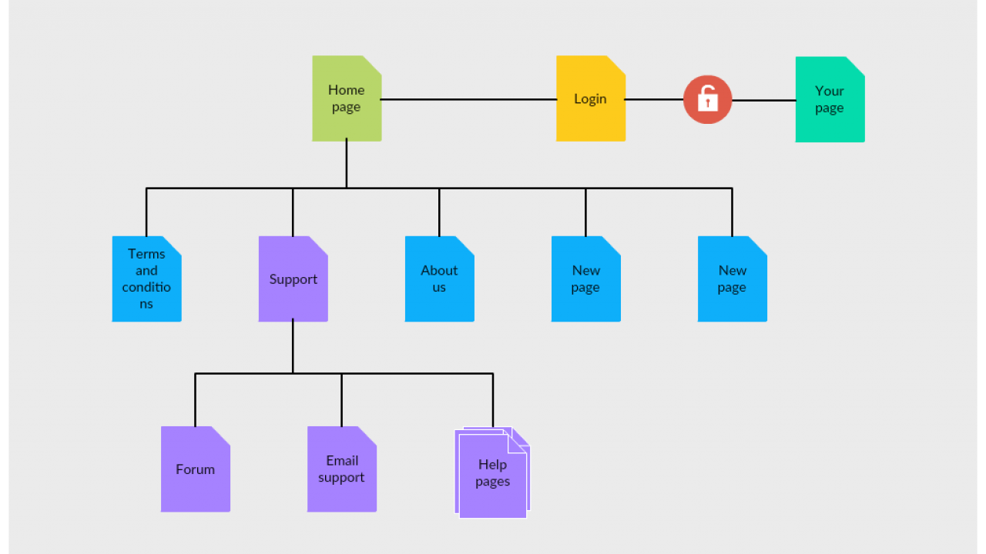

.

### Class Diagram

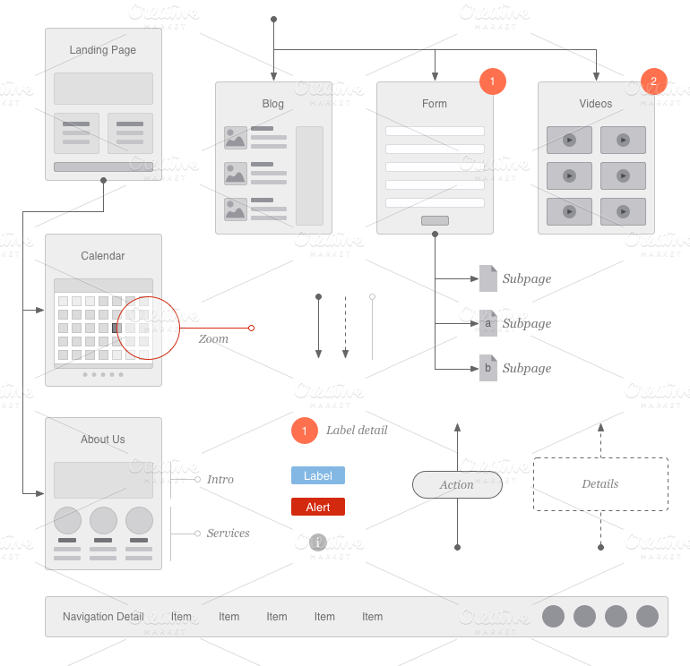

#### Data Flow Diagram

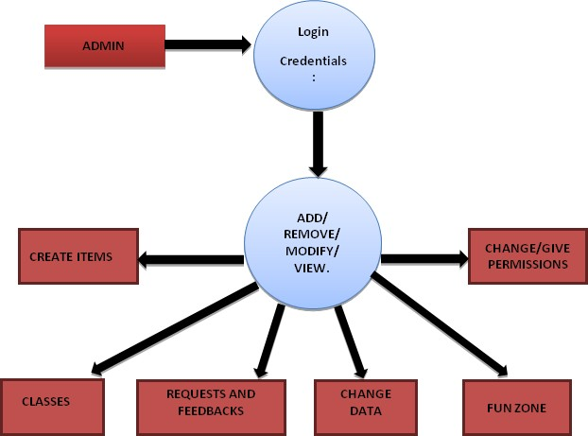

## CHAPTER-4

### TECHNOLOGY USED

#### Full - Stack

In the world of software programming, it helps to have someone on the team who is something of a jack of all trades. They can help with various stages of development and have the versatility and time management to assist all levels of the development team. When it comes to web development, that role belongs to the Full Stack Developer. This is not a Back End or Front End developer, but someone who handles both — a “Full Stack,” as it was.

A Full Stack Developer is someone who works with the Back End — or server side — of the application as well as the Front End, or client side. Full Stack Developers have to have some **skills in a wide variety of coding niches**, from databases to graphic design and UI/UX management in order to do their job well. They are something of a swing, ready to assist wherever needed in the process.

Full Stack Developers are highly intelligent people who have trained through their education or through years in related fields on the job force. These jobs are **in high demand**, but employers don’t want to trust their web development to just anyone. There are certain standards of education and work experience that Full Stack Developers have to meet to be hired.

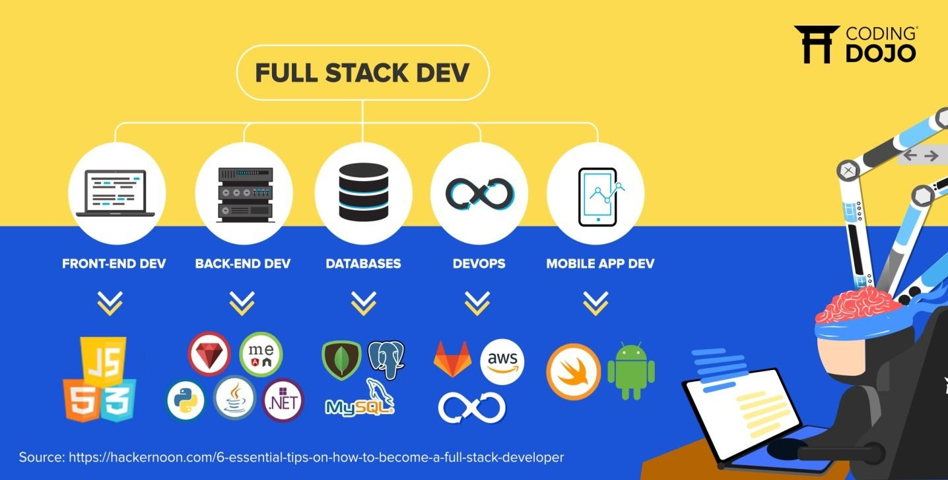

### Programming Languages Used

* + - **HTML**: HTML stands for Hyper Text Markup Language. HTML describes the structure of web pages using markup. It is used to provide the content (words, images, audio, video, and so on) to the web pages. It is a tag based language. They are defined within the angle brackets. HTML file can be created using a text editor.
    - **CSS**: CSS stands for Cascading Style Sheets. CSS describes how HTML elements are to be presented on screen. CSS can control the layout of multiple web pages all at once. Also, includes adding visuals like color, fonts, layouts, etc.
    - **JavaScript**: JavaScript is based on functional programming. Therefore, functions are fundamental building blocks of JavaScript. Function contains set of statements that perform some task. You define a function using 'function' keyword.
    - **Bootstrap**: Bootstrap is an HTML, CSS & JS Library that focuses on simplifying the development of informative web pages (as opposed to web apps). The primary purpose of adding it to a web project is to apply Bootstrap's choices of color, size, font and layout to that project.
    - **Java**: Java is a programming language and computing platform. Java is a general- purpose, class-based, object-oriented programming language designed for having lesser implementation dependencies. It is a computing platform for application development. Java is fast, secure, and reliable, therefore. It is widely used for developing Java applications in laptops, data centers, game consoles, scientific supercomputers, cell phones, etc.

**PHP** (Hypertext Preprocessor)**:** is known as a **general-purpose scripting language that can be used to develop dynamic** **and interactive websites**. It was among the first server-side languages that could be embedded into HTML, making it easier to add functionality to web pages without needing to call external files for data.

## CHAPTER -5

### IMPLEMENTATION AND USER INTERFACE

Creating an Website concept design with screen sketches, functional flow diagrams, and ER diagrams is the best way to communicate your vision to the full stack developer. Making the concept clear to the developer is probably the most important factor in full stack development. Yet it is one of the most common problems or obstacles in a full stack development outsourcing project.

No matter what the marketing and profit goals are or if you are outsourcing an app for your personal use, you need to fully design and document the app concept if you expect a programmer to make your vision a reality. Developers are not mind readers and even descriptions given during conversations can be very fleeting or interpreted differently. Fully documenting your concept, therefore, leaves little to chance.

The two most important things to do are:

1. make a comprehensive description of how the Website works and what it does (functionality), and
2. create a comprehensive description of what the user sees and does (look and feel).
   1. **Implementation:**

Implementation simply means carrying out the activities described in your work plan. [Executing](https://sswm.info/content/executing) a project in the water and sanitation sector is a very complex mission, as it requires the coordination of a wide range of activities, the overseeing of a team, the management of budget, the [communication](https://sswm.info/content/communication) to the public, among other issues. Independent of whether it is a social project to raise the awareness and promote hygiene or it is a construction project for service delivery, there is a certain process that has to be followed. The following lines will give you an introduction into the implementation of projects in sustainable sanitation and water management, and highlights key aspects that have to be taken into account for a successful implementation.

Implementation of **GLA-CSED** is done in various phases:

* + - Firstly, we had built the login/signup interface.
    - Then, we had move towards the classes page, and started some work over the backend part.
    - After that, we went over to design the Landing page.
    - Next, we went over the Contact and Support page of the Landing page.
    - Then, towards the project page.
    - Last, we have About Us and Blog page.

#### Different Modules Present:

**Front end Module:**

The front-end of a website is the part that users interact with. Everything that you see when you're navigating around the Internet, from fonts and colors to dropdown menus and sliders, is a combo of HTML, CSS, and JavaScript being controlled by your computer's browser.

**Backend Module:**

The backend (or “server-side”) is the portion of the website you don't see. It's responsible for storing and organizing data, and ensuring everything on the client-side actually works. The backend communicates with the frontend, sending and receiving information to be displayed as a web page.

**Database Module:**

A web database is a system for storing information that can then be accessed via a website. For example, an online community may have a database that stores the username, password, and other details of all its members. ... At its most simple level, a web database is a set of one or more tables that contain data.

#### User Interfaces:

###### Home:

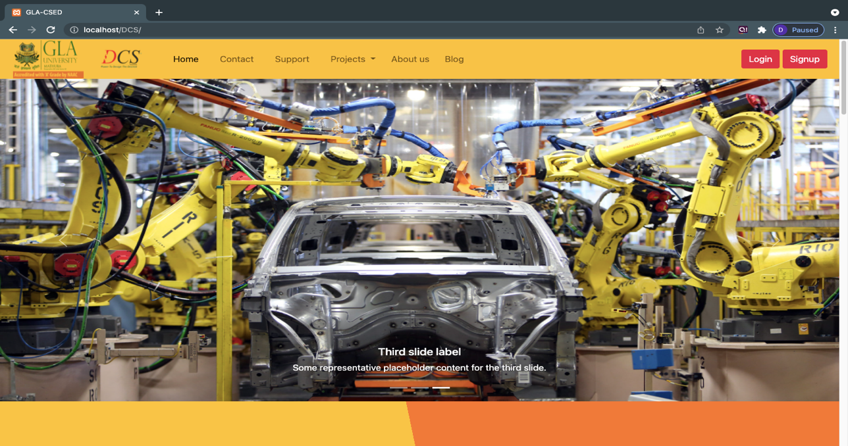

**Signup:**

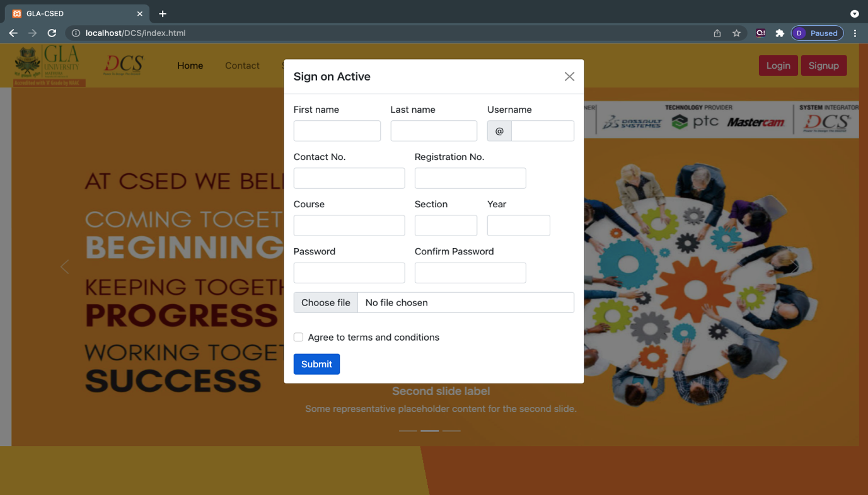

Dept. of CEA, GLAU, Mathura Page 13

###### Contact:

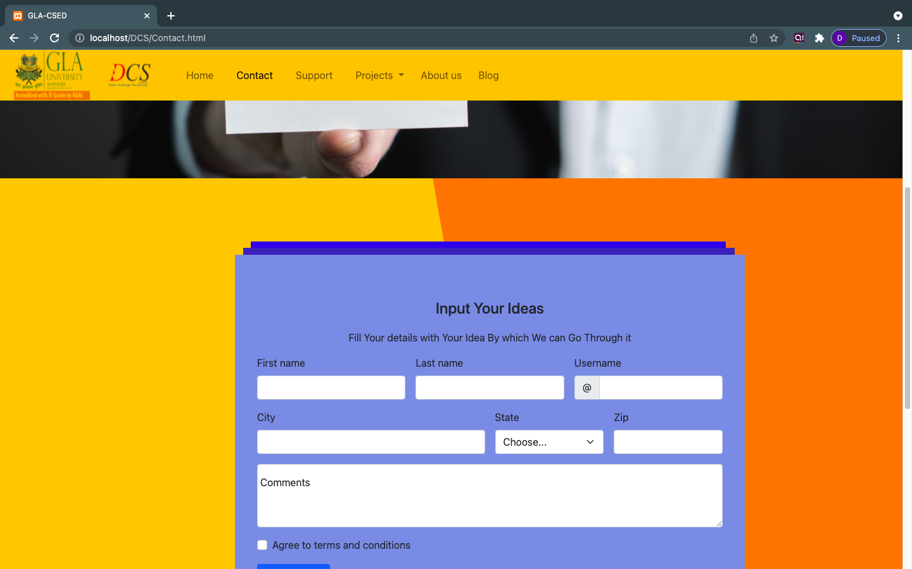

**Contact footer:**

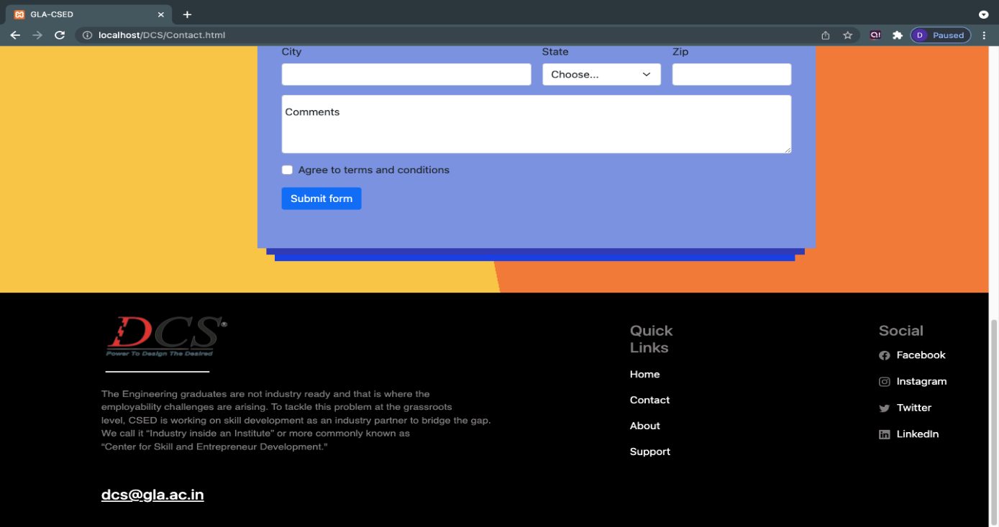

**Support Page:**

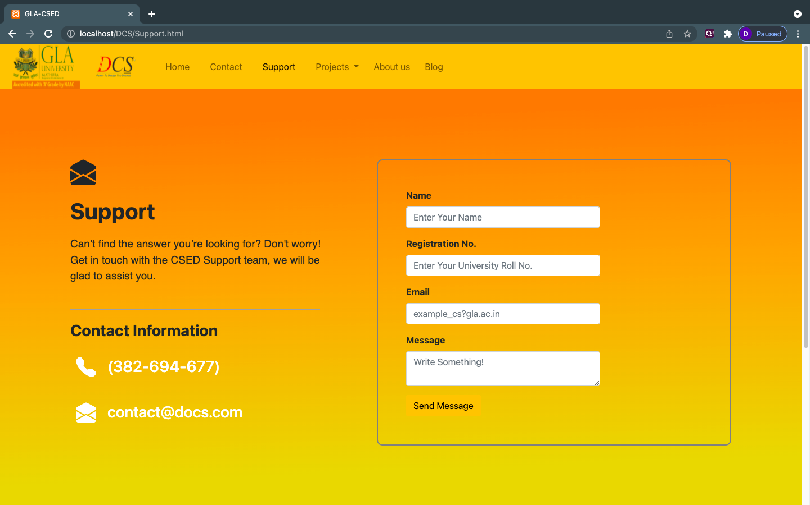

**About us page:**

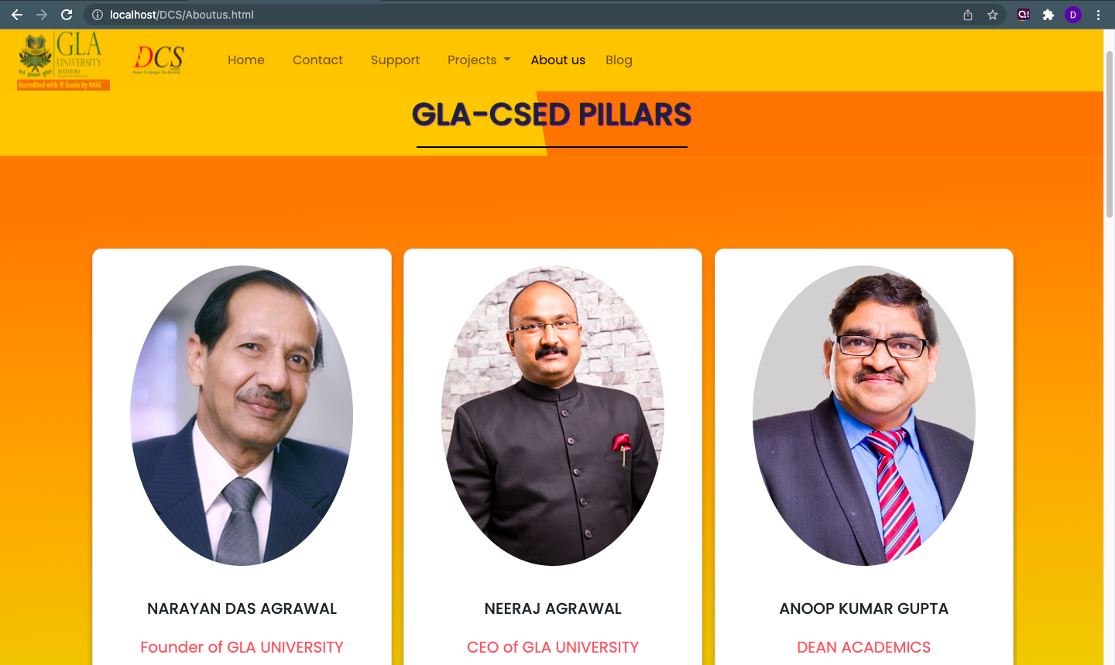

**About Us Page:**

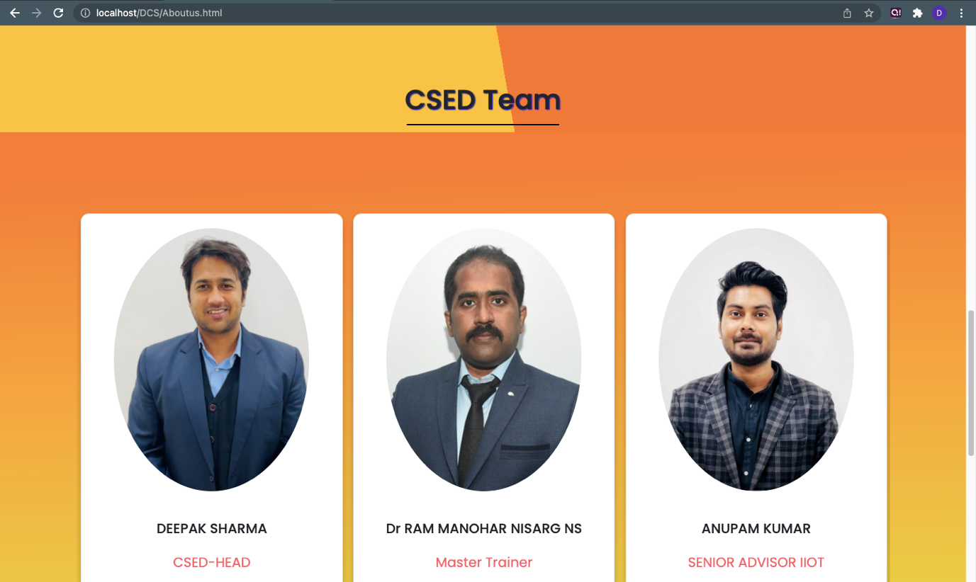

**Blog page:**

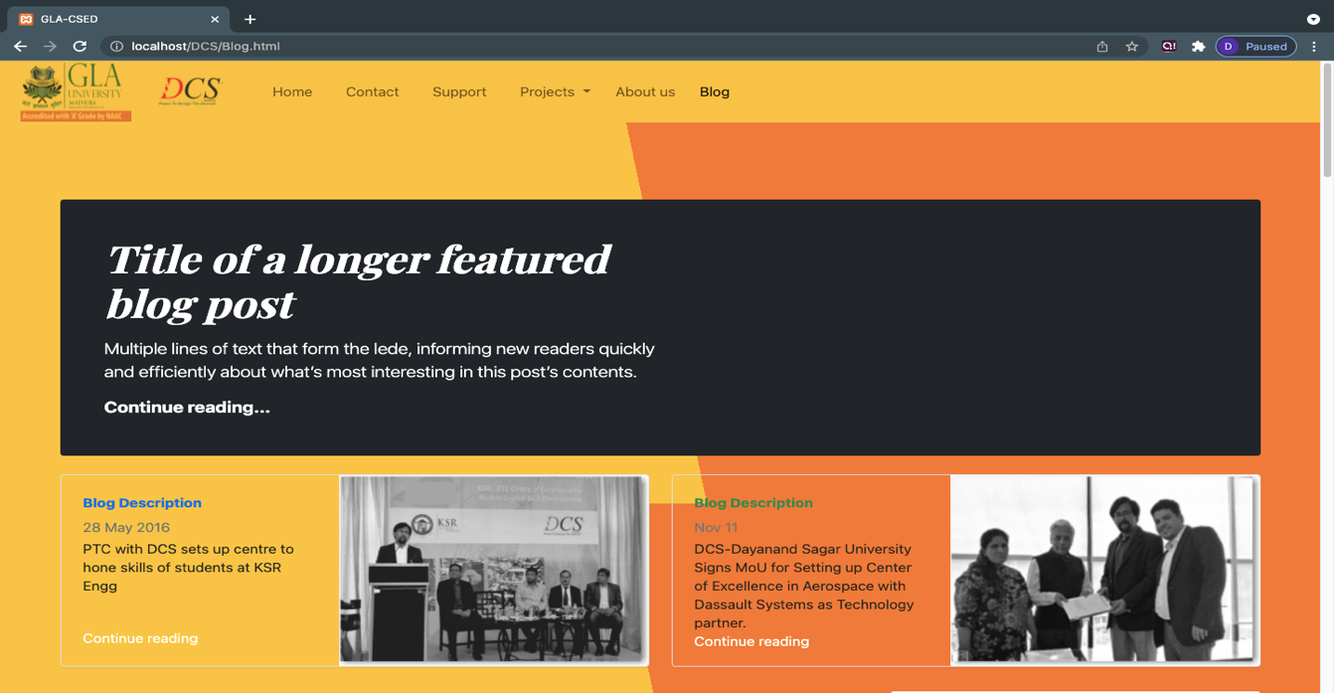

**Blog Page:**

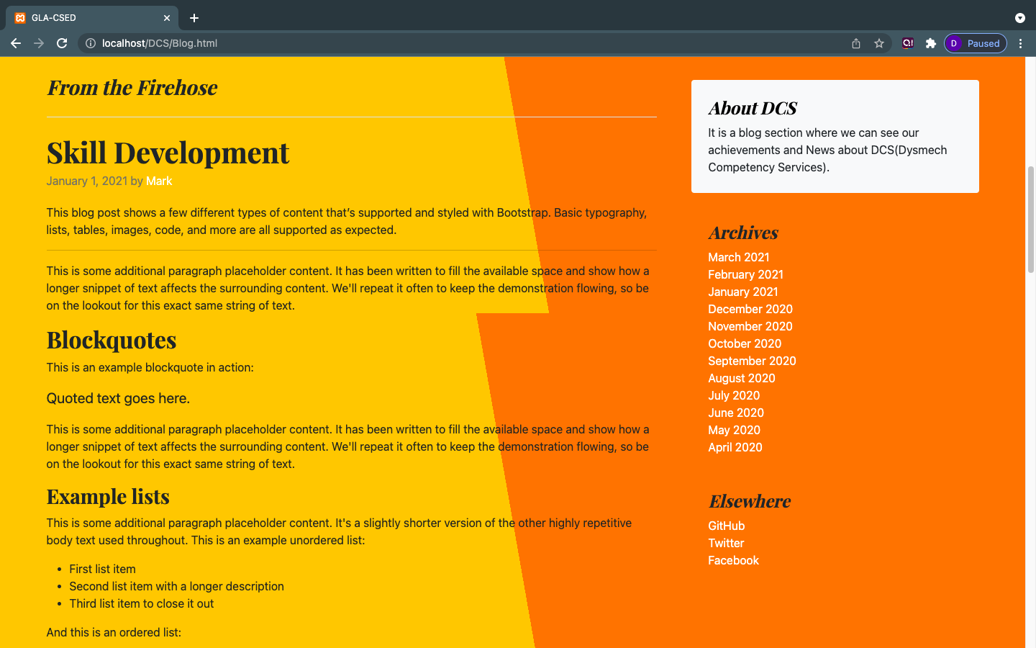

**Blog page:**

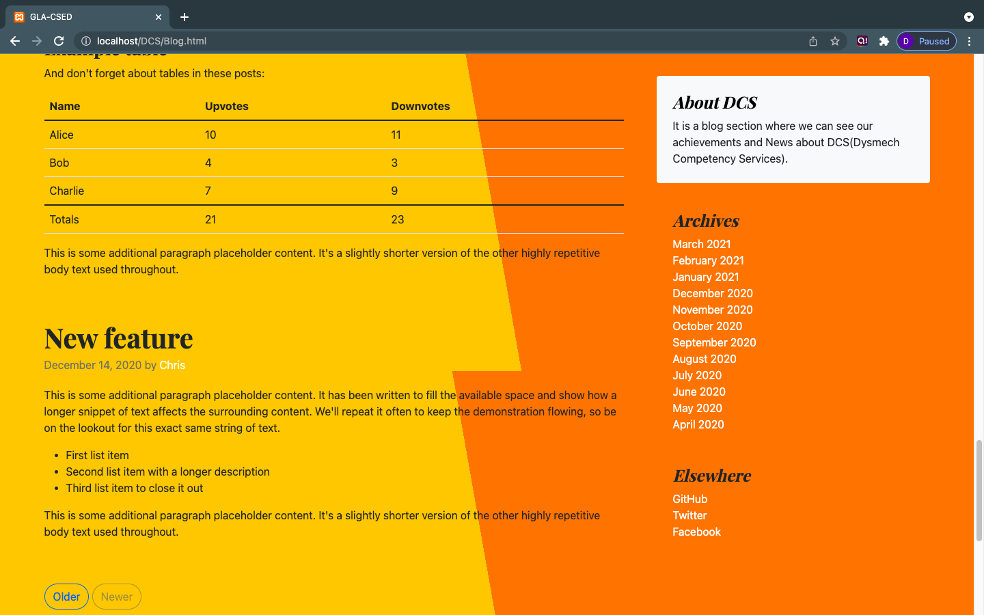

**Blog Page:**

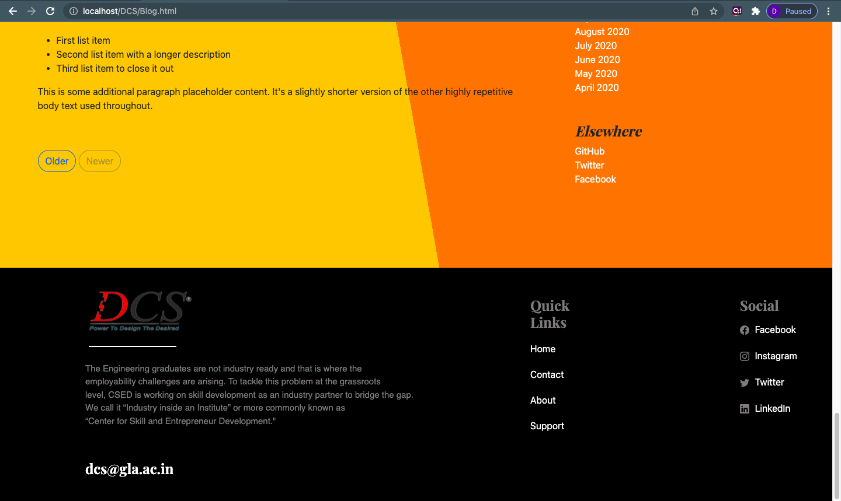

**Projects menu page:**

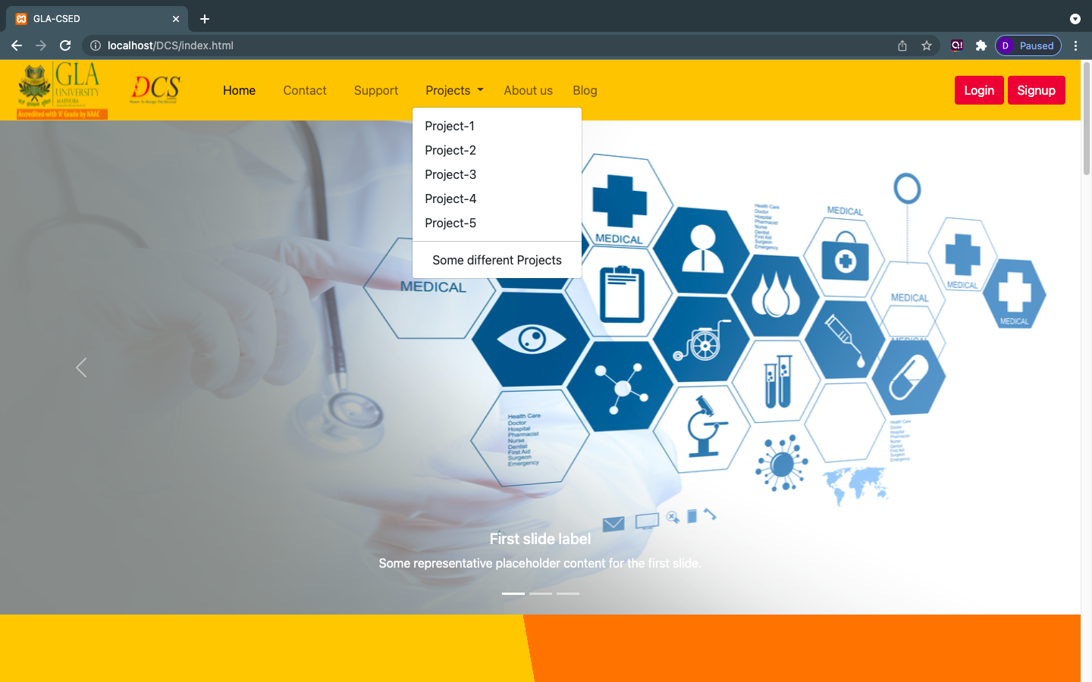

**Project-1 Pages:**

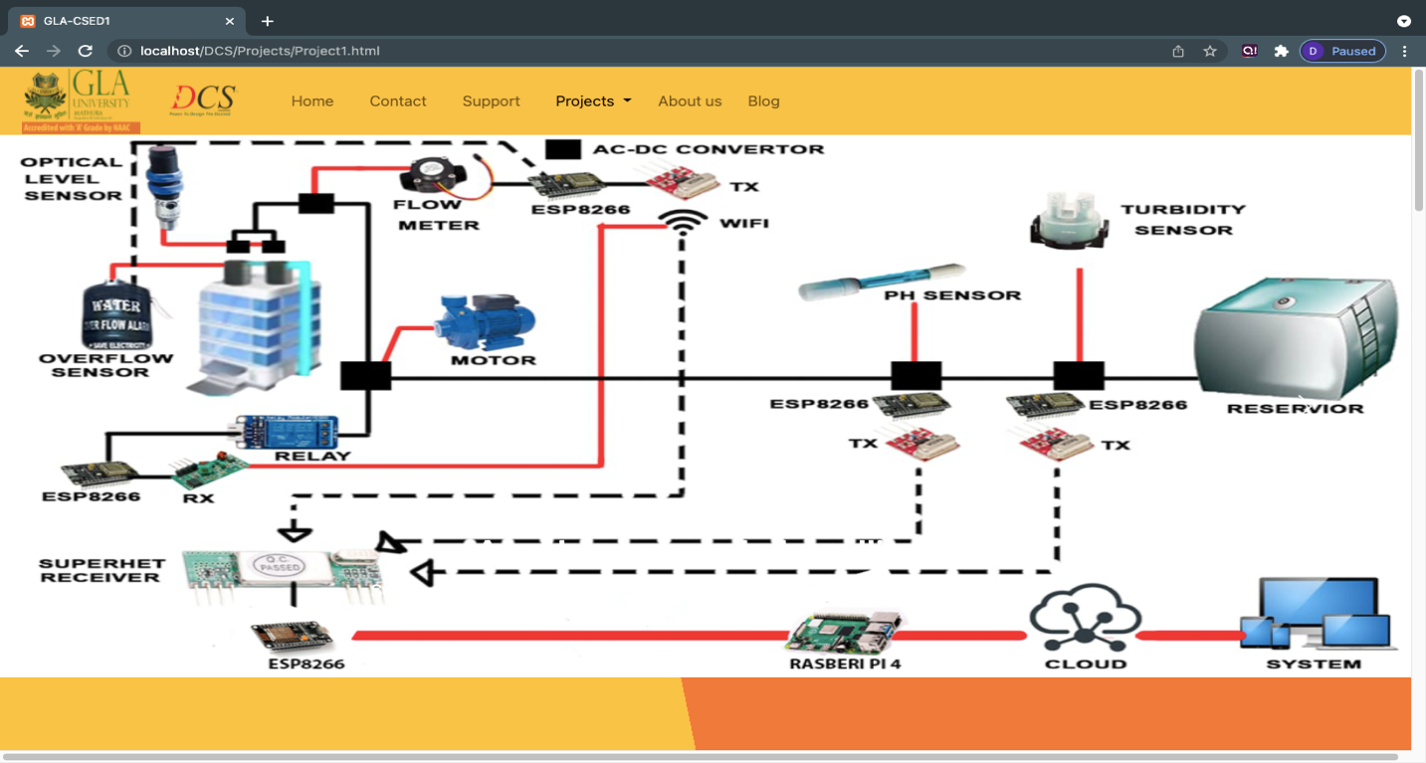

**Project-1 pages:**

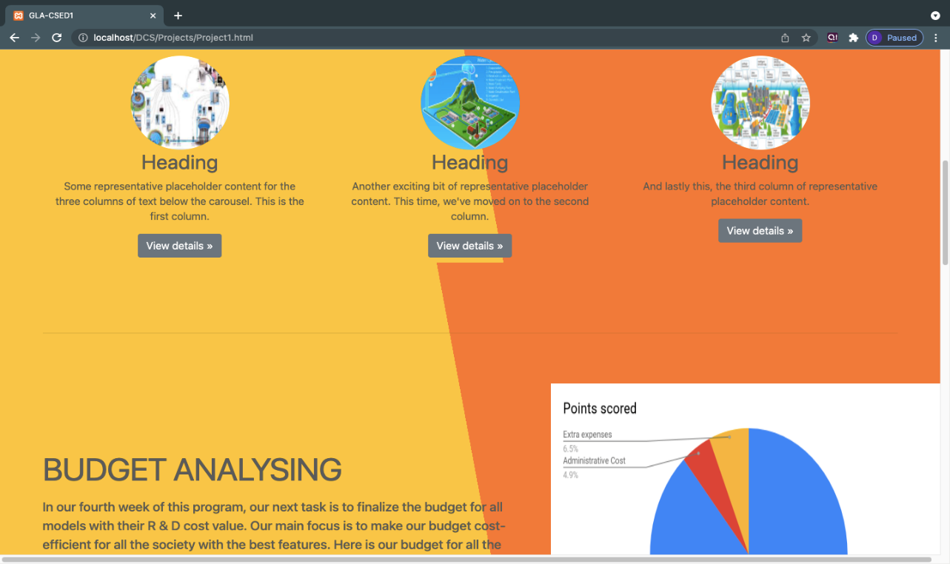

**Project-2 Pages:**

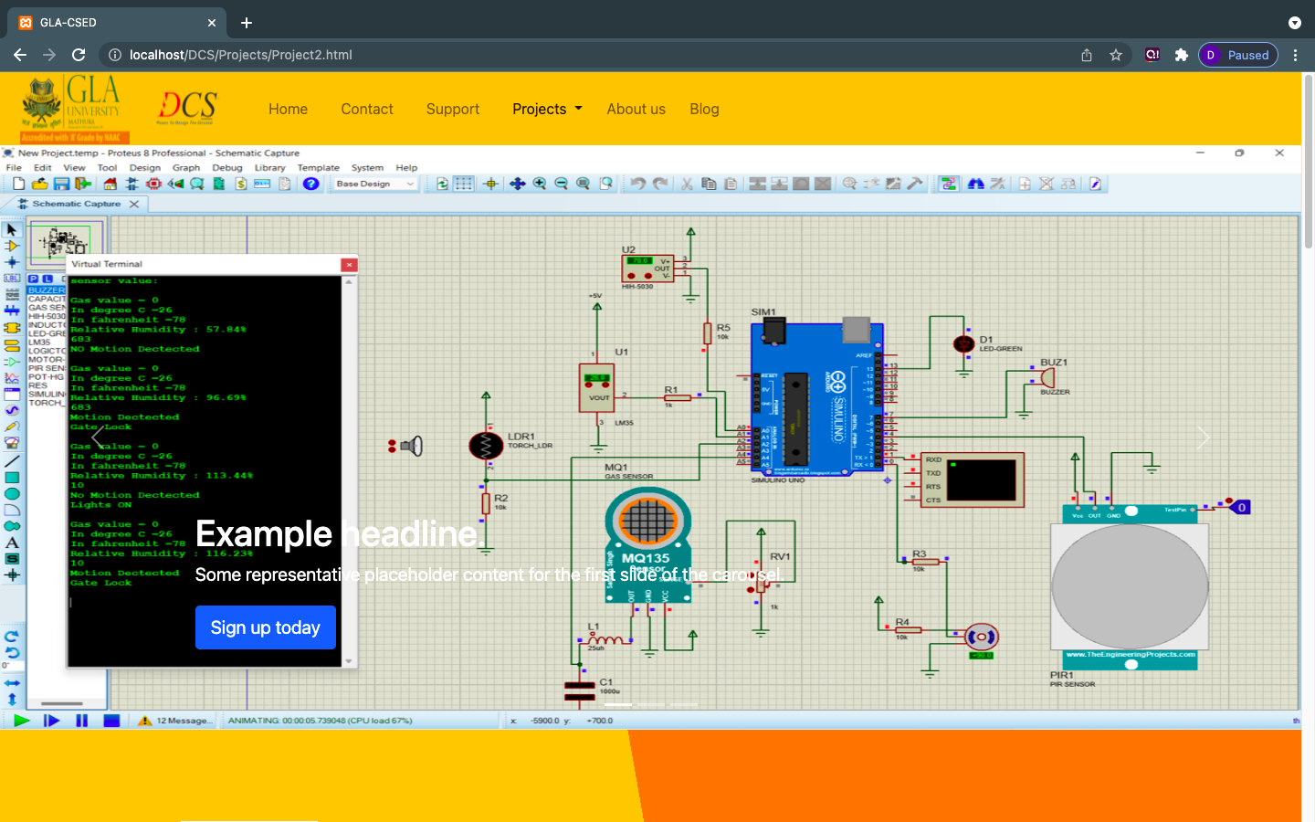

**Project-2 pages:**

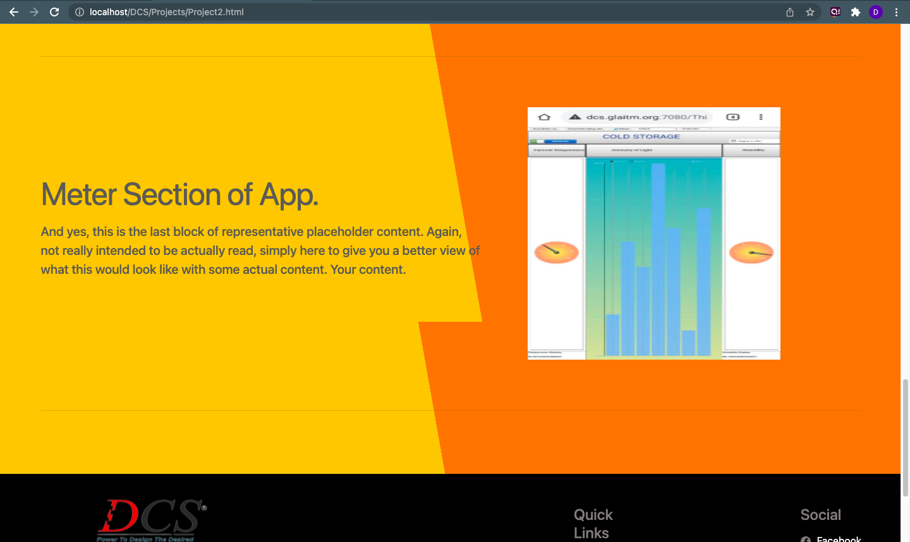

* 1. **Flow Chart for submitting the assignment:**



CHAPTER - 6

### TESTING

Once source code has been generated, software must be tested to uncover as many errors as possible before delivery. It is very important to work the system successfully and achieve high quality of software. Testing include designing a series of test cases that have a high likelihood of finding errors by applying software-testing techniques.

Loading Testing is defined as a server testing type, conducted through scripts with the motive of finding errors in server. It deals with tests for the entire Website.

System testing makes logical assumptions that if all the parts of the system are correct, the goal will be successfully achieved. The system should be checked logically. Validations and cross checks should be there. Avoid duplications of record that cause redundancy of data.

In other words, Testing is the process of evaluating a system or its component(s) with the intent to find whether it satisfies the specified requirements or not. It is executing a system in order to identify any gaps, errors, or missing requirements in contrary to the actual requirements.

There are different types of testing some of them are listed below:

* 1. **Loading Testing:**

As we know that every Website should be responsive on each existing devices. Thus, the Loading testing of the Website is done by all the teammates to ensure the responsiveness of the Website on every device.

Also, ensured the smooth working of the Website without ending up the errors, etc.

* 1. **Unit Testing**

It focuses on smallest unit of software design. In this we test an individual unit or groups of inter related units. It is often done by programmer by using sample input and observing its corresponding outputs. In this testing technique we are primarily focuses on

* + - Loop methods and function is working fine or not.
    - Misunderstood or incorrect Arithmetic precedence
    - Incorrect Initialization

###### Unit Testing of the app:

|  |  |  |  |
| --- | --- | --- | --- |
| **Test cases** | **Description** | **Expected Outcome** | **Result** |
| **1** | Home – Login /Signup Page | Should display login/signup form with popup. | **Pass** |
| **2** | Contact Page | Form to Contact the website admistration(i.e, CSED) | **Pass** |
| **3** | Support Page | Should display the form of the support page for ideas. | **Pass** |
| **4** | project Page | Should display the projects performed practically in the CSED lab. | **Pass** |

#### User Testing

User testing is the process through which the interface and functions of a website, product, or service are tested by real users who perform specific tasks in realistic conditions. The purpose of this process is to evaluate the usability of that website and to decide whether the product is ready to be launched for real users.

This website was tested by our team mates and friends who are using different laptop screen (and having different screen sizes) also tested on local server to check its performance and it seems to be working fine and users of this Website are satisfied with the facilities and performance of the Website and like the way how the website is worked.

##### Performance Testing

Performance Testing is a software testing process used for testing the speed, response time, stability, reliability, scalability and resource usage of a software Website under particular workload.

The focus of Performance Testing is checking a software program’s

* + - Speed – Determines whether the website responds quickly.
    - Scalability – Determines maximum user load the software website can handle.
    - Stability – Determines if the website is stable under varying loads.

Performance testing in a project can be used as a diagnostic aid to locate computing or communications bottlenecks within a system. Bottlenecks are a single point or component within a system's overall function that holds back overall performance. For example, even the fastest computer will function poorly on the web if the bandwidth is less than 1 megabit per second ([Mbps](https://www.techtarget.com/searchnetworking/definition/Mbps)).

In this type of testing we have checked the performances of our application under some peculiar conditions are checked. Those conditions include:

* + - * Poor/Bad network reception.
      * Use of non – certified browsers

Performance is basically tested from 2 ends, website end, and the website server end. Our application is also performing well in this phase of testing as well. And we are getting positive feedback from the users of our website.

##### 6.5 Compatibility Testing

This website was tested and used on different devices. The website worked fine and is stable. The website worked fine in portrait mode and there isn't any problem with compatibility.

*On all types of testing (that we have performed above) are performing well on our website i.e.* ***GLA-CSED Website.***

## CHAPTER **-7**

### CONCLUSION

Industrial Training has brought a positive impact in the lives of students and working professionals. It has given an opportunity to take up additional courses along with their studies or job as per their convenience. Industrial Training has also helped the faculty in the institutions to ask students to learn Industry Work experience which can’t be possible in academics. So the Industrial Training helps the faculty to save time in which they can interact with the students more.

**GLA-CSED Website** is probably best described as a good start. It's intuitive, with plenty of genuinely useful features for faculties and students, and could actually help to reach the students in such a Easy way.

**GLA-CSED Website** seems perfect for students in college that don't have a industrial training platform. For Industrial Training,

It comes up with properties like:

* + - incorporate technology in their curriculum and makes you a industry ready.
    - provide more resources to their students in an easier way.

In summary, GLA-CSED Website can be treated as a free website platform that was introduced for college’s that work to get project idea’s and get them implemented. This blended platform saves great ideas! It allows admin’s to make students communicate to best faculties, and give them opportunities to make their idea coming True practically. This CSED program was introduced two years ago and continues to grow in interest.

*I’m not telling you it’s going to be* ***easy,***

*I’m telling you it’s going to be* ***WORTH IT****.*

# REFERENCES

###### W3Schools:

[**https://www.w3schools.com/**](https://www.w3schools.com/)

* **Wikipedia:**

[**https://en.wikipedia.org/?title=Full_stack&redirect=no**](https://en.wikipedia.org/?title=Full_stack&redirect=no)

* **Stack-overflow:**

[**https://stackoverflow.com/**](https://stackoverflow.com/)

* **Beta-Labs:**

[**https://www.beta-labs.in/**](https://www.beta-labs.in/)

**Google Drive Link for Project:**

***https://mega.nz/folder/mcBiSDgA#KmvOV4bW-tQaR1f67fF9LA***